Laravel stappen

================================================================================================================================

php artisan make:model Product -a

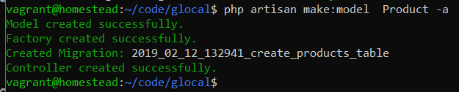

vagrant@homestead:~/code/glocal$ php artisan make:model Product -a

Model created successfully.

Factory created successfully.

Created Migration: 2019_02_12_132941_create_products_table

Controller created successfully.

vagrant@homestead:~/code/glocal$

php artisan make:seeder ProductsTableSeeder



vagrant@homestead:~/code/glocal$ php artisan make:seeder ProductsTableSeeder

Seeder created successfully.

vagrant@homestead:~/code/glocal$

================================================================================================================================

Php’s to edit:

c:\share\laravel\glocal\database\migrations\2019_02_12_132941_create_products_table.php

c:\share\laravel\glocal\app\ Product.php

c:\share\laravel\glocal\database\seeds\ProductsTableSeeder.php

c:\share\laravel\glocal\database\seeds\ DatabaseSeeder.php

================================================================================================================================

\glocal\database\migrations\2019_02_12_132941_create_products_table.php

public function up()

{

Schema::create('products', function (Blueprint $table) {

$table->increments('id');

$table->string('productName');

$table->integer('productCategory');

$table->string('productDescription');

$table->float('productPrice');

$table->string('productImage');

$table->timestamps();

});

}

================================================================================================================================

\glocal\app\Product.php

class Product extends Model

{

//

protected $fillable = [

'productName',

'productCategory',

'productDescription',

'productPrice',

'productImage',

];

}

================================================================================================================================

\glocal\database\seeds\ProductsTableSeeder.php

public function run()

{

//------------------------------------------------------------------------

DB::table('products')->insert(

[

['productName' => 'Donald Duck Album 1',

'productCategory' => 1,

'productDescription' => 'Donald Duckieeeeeeeee',

'productPrice' => 2.50,

'productImage' => 'href',

],

['productName' => 'Playstation 4',

'productCategory' => 2,

'productDescription' => 'Game Console',

'productPrice' => 395.00,

'productImage' => 'href',

],

['productName' => 'Black Label 1 liter',

'productCategory' => 3,

'productDescription' => 'Wishkey 40%',

'productPrice' => 50.00,

'productImage' => 'href',

]

]);

//------------------------------------------------------------------------

}

}

================================================================================================================================

\glocal\database\seeds\DatabaseSeeder.php

public function run()

{

// $this->call(UsersTableSeeder::class);

$this->call(CategoriesTableSeeder::class);

$this->call(ProductsTableSeeder::class);

}

================================================================================================================================

php artisan migrate:refresh --seed

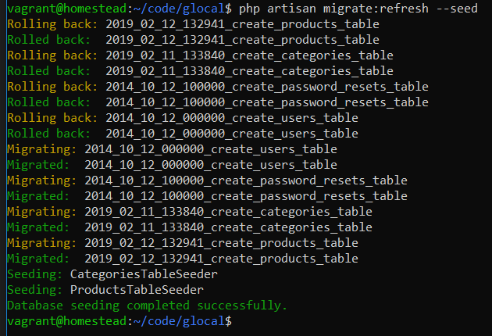

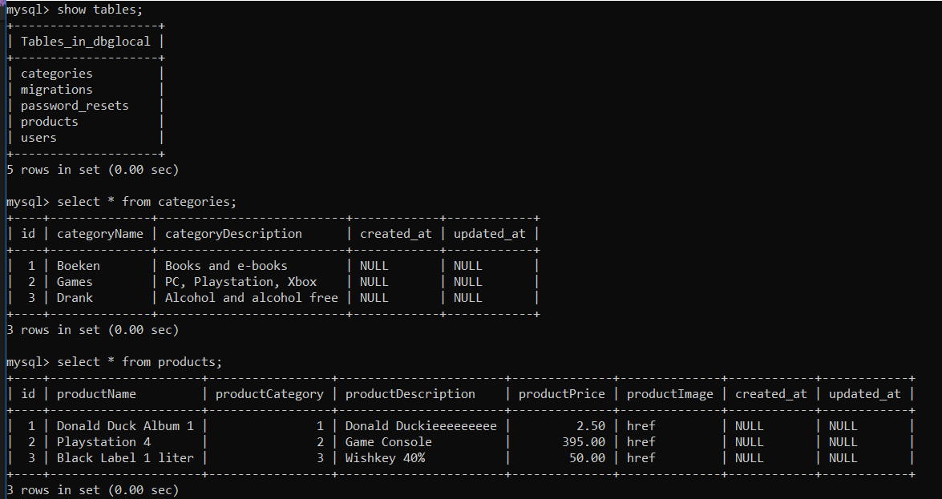

================================================================================================================================

\glocal\routes\web.php

Route::get('/', function () {

return view('welcome');

});

Route::resource('categories', 'CategoryController');

Route::resource('products', 'ProductController');

Auth::routes();

================================================================================================================================

Php artisan route:list

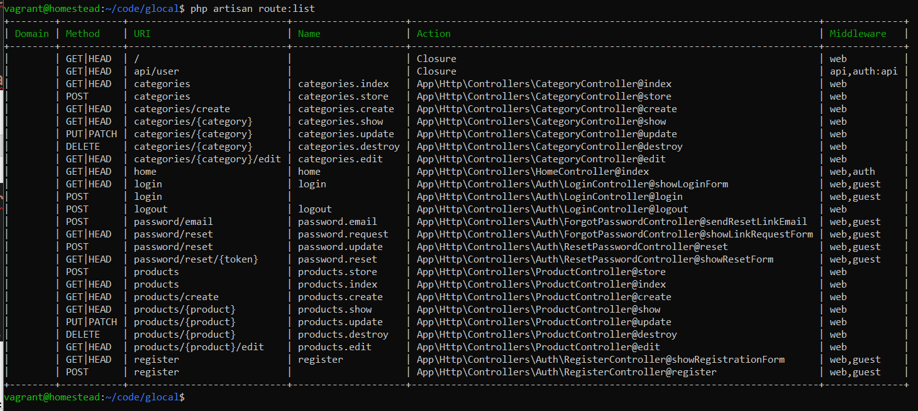

================================================================================================================================

Wijzig ProductController.php

\glocal\app\Http\Controllers\

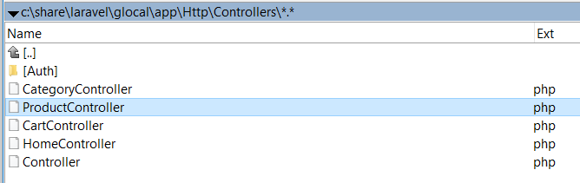

================================================================================================================================

Maak in de vieuws een products directory aan waar de volgende blades in komen

edit

create

index

\laravel\glocal\resources\views\products\

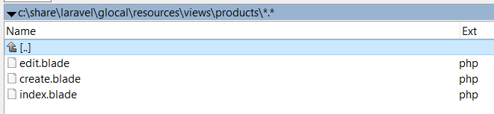

================================================================================================================================

ProductController.php

<?php

namespace App\Http\Controllers;

use App\Product;

use Illuminate\Http\Request;

class ProductController extends Controller

{

/**

* Display a listing of the resource.

*

* @return \Illuminate\Http\Response

*/

public function index()

{

//

//--------------------------------------------------------------------

$products = Product::all();

return view('products.index', compact('products'));

//--------------------------------------------------------------------

}

/**

* Show the form for creating a new resource.

*

* @return \Illuminate\Http\Response

*/

public function create()

{

//--------------------------------------------------------------------

return view('products.create');

//--------------------------------------------------------------------

}

/**

* Store a newly created resource in storage.

*

* @param \Illuminate\Http\Request $request

* @return \Illuminate\Http\Response

*/

public function store(Request $request)

{

//

//----------------------------------------------------------------

$request->validate([

'productName'=>'required',

'productPrice'=> 'required'

]);

$share = new Product([

'productName' => $request->get('productName'),

'productCategory' => $request->get('productCategory'),

'productDescription' => $request->get('productDescription'),

'productPrice' => $request->get('productPrice'),

'productImage' => $request->get('productImage')

]);

$share->save();

return redirect('/products')->with('success', 'Product has been added');

//----------------------------------------------------------------

}

/**

* Display the specified resource.

*

* @param \App\Product $product

* @return \Illuminate\Http\Response

*/

public function show(Product $product)

{

//

}

/**

* Show the form for editing the specified resource.

*

* @param \App\Product $product

* @return \Illuminate\Http\Response

*/

public function edit($id)

{

//

//--------------------------------------------------------------------

$product = Product::find($id);

return view('products.edit', compact('product'));

//--------------------------------------------------------------------

}

/**

* Update the specified resource in storage.

*

* @param \Illuminate\Http\Request $request

* @param \App\Product $product

* @return \Illuminate\Http\Response

*/

// public function update(Request $request, Product $product)

public function update(Request $request, $id)

{

//------------------------------------------------------------------------------------------------

$request->validate([

//'productName'=>'required',

'productPrice'=> 'required'

]);

$product = Product::find($id);

$product->productName = $request->get('productName');

$product->productCategory = $request->get('productCategory');

$product->productDescription = $request->get('productDescription');

$product->productPrice = $request->get('productPrice');

$product->productImage = $request->get('productImage');

$product->save();

return redirect('/products')->with('success', 'Product has been updated');

//------------------------------------------------------------------------------------------------

}

/**

* Remove the specified resource from storage.

*

* @param \App\Product $product

* @return \Illuminate\Http\Response

*/

public function destroy($id)

{

//

//------------------------------------------------------------------------------------------------

$product = Product::find($id);

$product->delete();

return redirect('/products')->with('success', 'Product has been deleted Successfully');

//------------------------------------------------------------------------------------------------

}

}

================================================================================================================================

edit.blade.php

@extends('layout')

@section('content')

<style>

.uper {

margin-top: 40px;

}

</style>

<div class="card uper">

<div class="card-header">

Edit Share

</div>

<div class="card-body">

@if ($errors->any())

<div class="alert alert-danger">

<ul>

@foreach ($errors->all() as $error)

<li>{{ $error }}</li>

@endforeach

</ul>

</div><br />

@endif

<form method="post" action="{{ route('products.update', $product->id) }}">

@method('PATCH')

@csrf

<div class="form-group">

<label for="name">Product name:</label>

<input type="text" class="form-control" name="productName" value={{ $product->productName }} />

</div>

<div class="form-group">

<label for="category">Product category:</label>

<input type="integer" class="form-control" name="productCategory" value={{ $product->productCategory }} />

</div>

<div class="form-group">

<label for="description">Product description:</label>

<input type="text" class="form-control" name="productDescription" value={{ $product->productDescription }} />

</div>

<div class="form-group">

<label for="price">Product price:</label>

<input type="float" class="form-control" name="productPrice" value={{ $product->producPrice }} />

</div>

<div class="form-group">

<label for="image">Product image:</label>

<input type="text" class="form-control" name="productImage" value={{ $product->productPrice }} />

</div>

{{--

$table->string('productName');

$table->integer('productCategory');

$table->string('productDescription');

$table->float('productPrice');

$table->string('productImage');

--}}

<button type="submit" class="btn btn-primary">Update</button>

</form>

</div>

</div>

@endsection

================================================================================================================================

create.blade.php

@extends('layout')

@section('content')

<style>

.uper {

margin-top: 40px;

}

</style>

<div class="card uper">

<div class="card-header">

Add Product

</div>

<div class="card-body">

@if ($errors->any())

<div class="alert alert-danger">

<ul>

@foreach ($errors->all() as $error)

<li>{{ $error }}</li>

@endforeach

</ul>

</div><br />

@endif

<form method="post" action="{{ route('products.store') }}">

<div class="form-group">

@csrf

<label for="name">Product name:</label>

<input type="text" class="form-control" name="productName"/>

</div>

<div class="form-group">

<label for="category">Product Category:</label>

<input type="integer" class="form-control" name="productCategory"/>

</div>

<div class="form-group">

<label for="description">Product description:</label>

<input type="text" class="form-control" name="productDescription"/>

</div>

<div class="form-group">

<label for="price">Product price:</label>

<input type="float" class="form-control" name="productPrice"/>

</div>

<div class="form-group">

<label for="image">Product image:</label>

<input type="text" class="form-control" name="productImage"/>

</div>

<button type="submit" class="btn btn-primary">Add</button>

</form>

</div>

</div>

@endsection

================================================================================================================================

index.blade.php

@extends('layout')

@section('content')

<style>

.uper {

margin-top: 40px;

}

</style>

<div class="uper">

@if(session()->get('success'))

<div class="alert alert-success">

{{ session()->get('success') }}

</div><br />

@endif

{{-- href to create category --}}

<a href="{{ route('products.create')}}" class="btn btn-primary">Products + </a></td>

<table class="table table-striped">

<thead>

<tr>

<td>ID</td>

<td>Name</td>

<td>Category</td>

<td colspan="2">Action</td>

</tr>

</thead>

<tbody>

@foreach($products as $product)

<tr>

<td>{{$product->id}}</td>

<td>{{$product->productName}}</td>

<td>{{$product->productCategory}}</td>

<td>{{$product->productDescription}}</td>

<td>{{$product->productPrice}}</td>

<td>{{$product->productImage}}</td>

<td><a href="{{ route('products.edit',$product->id)}}" class="btn btn-primary">Edit</a></td>

<td>

<form action="{{ route('products.destroy', $product->id)}}" method="post">

@csrf

@method('DELETE')

<button class="btn btn-danger" type="submit">Delete</button>

</form>

</td>

</tr>

@endforeach

</tbody>

</table>

<div>

@endsection

================================================================================================================================

================================================================================================================================

================================================================================================================================